**Practical No. 6: Write a program using swing to display a ScrollPane and JComboBox in an JApplet with the items -English, Marathi, Hindi, Sanskrit.**

* **Program:**

import java.awt.*;

import java.awt.event.*;

import java.applet.*;

import javax.swing.*;

public class pract6_X extends JApplet implements ItemListener

{JComboBox ch = new JComboBox();

    JLabel l;

    public void init()

    {Container c = getContentPane();

        c.setLayout(new FlowLayout());

        l = new JLabel("");

        ch.addItem("Solapur");

        ch.addItem("Pune");

        ch.addItem("Banglore");

        ch.addItem("Mumbai");

        c.add(ch);

        c.add(l);

        ch.addItemListener(this);

    }

    public void itemStateChanged(ItemEvent e)

    {String s = (String)ch.getSelectedItem();

        l.setText("You are in " + s);}

}

/*

<applet code=pract6_X.class width=300 height=300> </applet>

*/

**Output:**

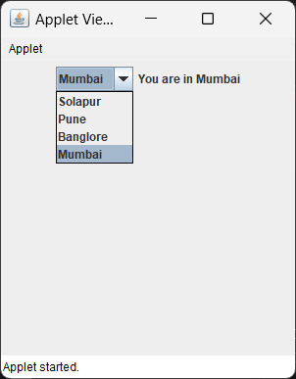

* **Write program to develop a frame to select the different states of India using JComboBox.**

**Program:**

import java.awt.*;

import java.applet.*;

import javax.swing.*;

public class pract6_ex1 extends JApplet

{ ComboBox jc = new JComboBox<>();

    public void init()

    {Container c = getContentPane();

        c.setLayout(new FlowLayout());

        jc.addItem("Maharashtra");

        jc.addItem("Punjab");

        jc.addItem("Gujrat");

        jc.addItem("Madhya Pradesh");

        jc.addItem("Uttar Pradesh");

        jc.addItem("Goa");

        jc.addItem("Karnataka");

        jc.addItem("Manipur");

        jc.addItem("Haryana");

        jc.addItem("Tamil Nadu");

        c.add(jc);

    }}

/*

<applet code=pract6_ex1.class width=300 height=300> </applet>

*/

**Output:**

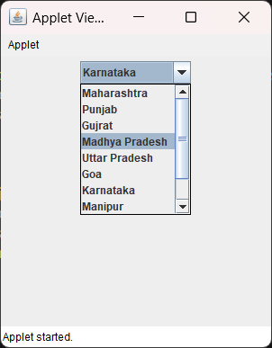

* **Write a program to demonstrate the use of ScrollPane in Swings.**

**Program:**

import java.applet.*;

import java.awt.*;

import javax.swing.*;

public class pract6_ex2 extends JApplet

{public void init()

    {Container c = getContentPane();

        c.setLayout(new BorderLayout());

        JPanel jp = new JPanel();

        jp.setLayout(new GridLayout(20, 20));

        int b = 0;

        for(int i = 0; i < 5; i++) {

        for(int j = 0; j < 5; j++) {

        jp.add(new JButton("Button " + b));

        ++b;}}

        int v = ScrollPaneConstants.VERTICAL_SCROLLBAR_ALWAYS;

        int h = ScrollPaneConstants.HORIZONTAL_SCROLLBAR_ALWAYS;

        JScrollPane jsp = new JScrollPane(jp, v, h);

        c.add(jsp, BorderLayout.CENTER);

   }}

/*

<applet code=pract6_ex2.class width=400 height=400>

</applet>

*/

**Output:**

